Recommended books will be available for check out at the book carts, located at each Welcome Desk (beginning May 24). Happy reading!
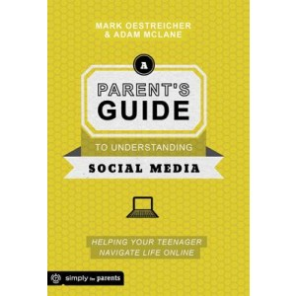
A Parent's Guide to Understanding Social Media: Helping Your Teenager Navigate Life Online by Mark Oestreicher
Recommended by Marissa Joyce: “Every parent's goal is to raise a responsible adult... but many feel unequipped to teach their children how to navigate the world of social media. This brief guidebook profiles different media platforms, the appeal of social media for your teens, how to navigate privacy, and good guidelines for rules concerning technology and social media use in your home. The highlight of the book, however, is the suggestions and encouragement for engaging your children in conversation about the what’s and the why's of social media in their life.”

Soul Keeping by John Ortberg 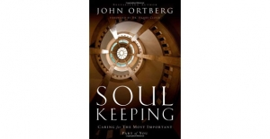
Recommended by Amy Carlan: It seems like at the close of 2014, I heard about this book everywhere I turned: in sermons, in meetings, and my go-to-friend for reading recommendations had read it three times already. And so I read it and was glad that I did. I think there is a reason the book has gotten so much air time: because each of us longs to connect with and take better care of our souls. Ortberg describes the book as “Dallas Willard for Dummies.” Willard was a brilliant theologian, philosopher, and caretaker of the soul. Ortberg shares what he learned from Willard about what the soul is and how to care for this most precious part of who we are as humans. Ortberg also candidly shares his personal struggles and growth. Read it – you’ll be glad you did.
ATTENTION SMALL GROUPS: There is a now a 6 week “Soul Keeping” DVD study! Each video segment is approximately 25 minutes long. Participant guides include group questions, a suggested group spiritual exercise (to be done by each person between sessions) and optional personal reflection questions. Reading the book is not necessary when using the DVD study guide, but it would enhance the study. A copy of the DVD guide, and an example of the participant’s guide are available in the Resource Room for check-out.
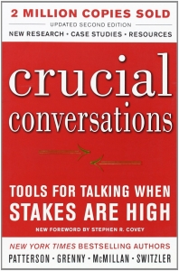 Crucial Conversations: Tools for Talking when Stakes are High by Joseph Grenny
Recommended by Mike Horne: Joseph Grenny is a researcher and social scientist whose research involving more than 100,000 people provides useful tools to help everyone get better at a vital skill in any relationship—critical conversations. A consistent top-rated speaker at the Global Leadership Summit, Grenny has a passion for helping everyone transform their relationships by helping individuals to learn how to dialogue with others over the things that matter in our daily lives.We all need conversations that are vital. Whether those conversations take place at work, at home, or at church, critical conversations can help strengthen our relationships. Grenny’s research and practical approach can help deepen how we relate to one another when opinions vary and emotions run high.
Love Does by Bob Goff
Recommended by Amanda Whalen: Love Does consists of 30 short chapters, each containing a story of some antic or experience from Bob Goff's life followed by a spiritual truth of sorts. Bob Goff is a lawyer as well as the founder and CEO of Restore International, a nonprofit organization fighting injustices committed against children, to which he donates the proceeds of this book. He writes, "I get the invitation every morning when I wake up to actually live a life of complete engagement, a life of whimsy, a life where love does." The only real connection among the various chapters of Bob's story is his deep conviction that God is profoundly, simply relational. Goff insists that "(Jesus) wants followers, not just onlookers or people taking notes."
ATTENTION SMALL GROUPS: There is a now a 5 week “Love Does” DVD study with a guide. The study includes an icebreaker question, a short video segment (9-15 minutes), reflection questions, and then a hand’s on exercise for your group to put love into action. There are also optional reflection questions and action suggestions that participants can do on their own between sessions. Reading the book is not necessary when using the DVD study guide, but it would enhance the study. A copy of the DVD guide, and an example of the participant’s guide are available in the Resource Room for check-out.
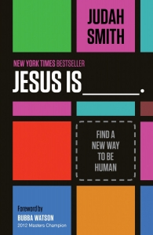 Jesus Is ____________ by Judah Smith
Recommended by Melinda Miller
This book is a great read. Judah Smith is a pastor in Seattle who loves Jesus and believes that the world should do the same. He wants people to meet Jesus, wherever they are, and live to be more like Jesus. His writing is humorous and thought provoking, but I believe he is just like you and me. I loved reading this one (more than once)!!!

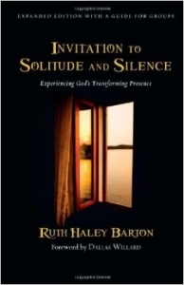
Invitation to Silence and Solitude by Ruth Haley Barton
Recommended by Carolyn Spencer
The short and easy read, Ruth Haley Barton invites one to explore the presence of God through the practice of meditation. This expanded edition includes a guide for groups to come in discussion and in learning to practice silence together or it is a simple explanation of how one can learn meditation slowly and deliberately for one’s individual use with very specific steps and practices. Each chapter provides spiritual guidance in how to achieve intimacy with God. The author uses Elijah’s story in 1 Kings where, after spending 40 days and nights in the desert, he felt protected from danger and anointed Elisha as his successor.
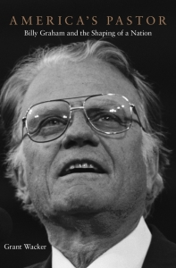 America’s Pastor: Billy Graham and the Shaping of a Nation by Grant Wacker
Recommended by Peter Barnes: In America's Pastor: Billy Graham and the Shaping of a Nation by Grant Wacker, the author doesn't write a traditional biography. Instead it is an interpretive study intended to deepen our understanding of why Billy Graham has mattered to so many, and how he became the most important shaper of evangelical Christianity in the 20th century? Wacker tries to answer questions like: How did a lanky farm kid from North Carolina become an evangelist hailed by the media as “America’s pastor”? Why did listeners young and old pour out their grief and loneliness in letters to a man they knew only through televised crusades in faraway places like Madison Square Garden? And how was it that Billy Graham became a confidant of presidents, and a person to preached the gospel face-to-face to more people than anyone in history. This volume is a dense book and a slow read. But it is worth the effort for anyone who wants to learn more about why Billy Graham matters. I commend it to you.
Simply Good News by NT Wright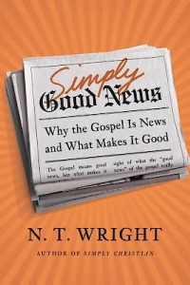
Recommended by Petey Crowder: “In Simply Good News, NT Wright points out that most of our language for the Gospel, or the Good News is actually just good advice. Instead, Wright says that “good news,” by it’s nature, must refer to an event that has happened in history--and this event, in turn, would be good news worth reorganizing our lives around! This book will give you new language to talk about the work of Jesus and challenge you to take a deeper look at all the ways the Gospel has implications for your life.”

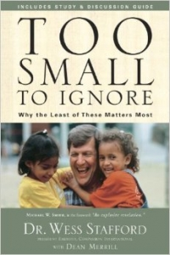Too Small to Ignore: Why the Least of These Matters Most by Dr. Wes Stafford
Recommended by Lorie Barnes: The book, Too Small to Ignore, by Dr. Wess Stafford is an inspiring book which challenges each of us to think about the importance of children, not only to us who are directly involved as parents, grandparents, teachers, coaches, etc. but also most importantly, how children are of high value to God. Wess tells his own moving and often humorous story as a child growing up in West Africa, and proceeds to demonstrate how the Bible gives us examples of children who are Biblical examples of God's special agents of mission! We discover that "the least of these" matters the most to God! Wess provides biblical groundwork for the theology of children and practical ways that we, as God's people, can face the modern day challenges of children- pornography, trafficking, hunger, protection and other issues. In a few short years, today's children will be managing the world's challenges! Now is the time to act on their behalf by investing in "the least of these!" Find out how you can be aware and involved!
Polishing the Petoskey Stone: Selected Poems by Luci Shaw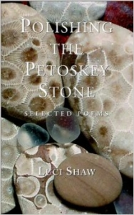
Recommended by Amy Carlan: Over the years, Michael Dodds has included poetry in some of our Advent worship services and special events. Heather Thomsen also included poetry in the Holy Week [spaces] services. I have loved these poems, and am drawn to ponder Christ more deeply because of their words, perspective, and beauty. Most of these poems are by Luci Shaw, a well known and respected poet, author, and editor. I have been eager to delve more deeply into Luci’s poetry, and plan to do so this summer through her most recent compilation of her best works. I hope you will join me in the adventure!
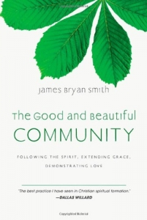 The Good and Beautiful Community by James Bryan Smith
In this third book in the Apprentice Series, James Bryan Smith helps us know how to live in relationship with others as apprentices of Jesus. "Apprentices of Jesus are not part-time do-gooders," he writes. "They live in continuous contact with the kingdom of God, and are constantly men and women in whom Christ dwells. They do not sometimes tell the truth, sometimes live sacrificially or sometimes forgive. There are myriad opportunities for us to impact the world in which we live." Yet many times we've gotten it wrong, tending to emphasize personal faith over social justice or vice versa. In these pages Jim Smith shows us how to bring spiritual formation and community engagement together, and then once again offers spiritual practices that root new, true narratives about God and the world in our souls. His insight and humility as a fellow learner with us will lead us to live in authentic ways as a good and beautiful community of Christ-followers, shining the light of the Spirit into every relationship. (www.amazon.com)

